Natural disasters: a refresher on preparation and procedure

MC900308643[1]~Emergency survival kits~

MC900308147[1]In the event of a disaster, being able to grab your essential items quickly and evacuate to a safe location is extremely important. Creating a survival kit, and keeping it in an easy to access location helps save time in the event of a disaster when you are in your house or apartment. The following is a comprehensive guide to making your own survival kit, as compiled by Melissa, the previous editor of The TOMBO. Along with a survival kit you should also prepare a small stockpile of other items you can retrieve if it is deemed safe to return to your home.

|  |  |
| --- | --- |
| **Melissa's Pricelist** | |
| Daiso 100Yen Shop | |
| Flashlight radio | 1365 |
| Candle | 315 |
| Lighters (4) | 105 |
| Tissue packs | 105 |
| Matches | 105 |
| Raincoat | 105 |
| Towel | 105 |
| 1st aid kit container | 105 |
| Band aids | 105 |
| Gauze | 105 |
| Masks | 105 |
| Scissors | 105 |
| Surgical tape | 105 |
| **Total** | **2835** |
| Power Drug One's | |
| Bufferin A (painkiller) 60 tabs | 980 |
| Anti-bacterial Ointment | 609 |
| Candy (2) | 176 |
| **Total** | **1765** |
| Supermarket | |
| Premium crackers | 177 |
| Ritz crackers | 168 |
| Skippy Peanut Butter | 415 |
| 2L Water | 189 |
| **Total** | **949** |
| **Grand Total** | **5549** |

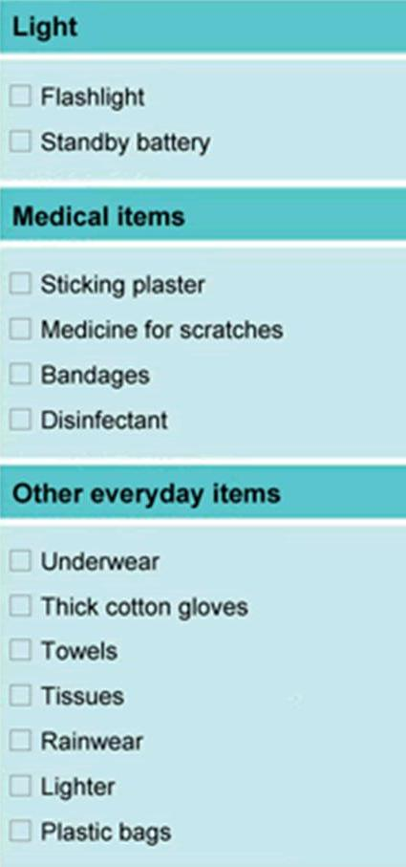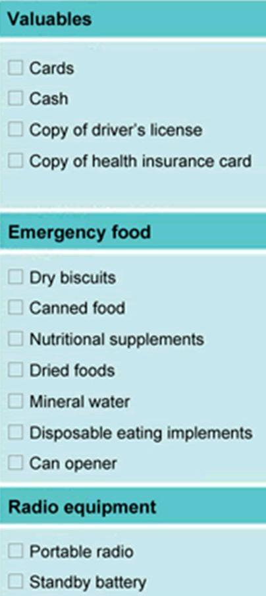**Survival Kit Checklist**

You should always keep your passport and alien registration card near you, and take them with you at the time of evacuation. Preparing copies of any important documents is also advised. You should also prepare glasses or contacts, medication and/or any other relevant personal items.

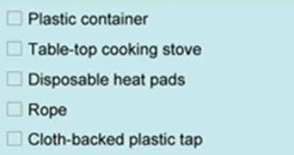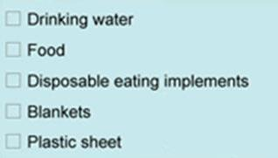**Stockpile Checklist**

Approximately 3 liters of drinking water should be allowed per person. Allow three days’ worth of boil-in-the-bag food and canned food.

The checklists were taken from The CLAIR Multilingual Living Information available at <http://www.clair.or.jp/tagengorev/en/index.html>